

STATEMENT OF ADVICE

Financial Planning Strategy
Prepared for:

Mrs Katrina Mills
Of

20 Erowal Street

BEAUMARIS VIC 3193

Prepared on:

6th August 2024

By your Adviser:

Andrew Lord B Bus (Acc.), Dip FS (Fin Plan)

Lakeside Financial

Suite 201, Level 2, 429 Bay Street
Brighton VIC 3186

Ph: 03 9596 5111 Fax: 03 9596 3222

Email: andrew.lord@lakesidefinancial.com.au
Authorised Representative # 324798
Pareto Group Pty Ltd
ABN 11 155 278 078 Australian Financial Services Licensee No. 418700
Suite 201, Level 2, 429 Bay Street, Brighton VIC 3186
Ph: 03 9596 5111 Fax: 03 9596 3222
What this document is about
This Statement of Advice (or SoA) is an important document.
- It provides you with information about our advice so you can make a decision about implementing the advice.
- It should be read in conjunction with other documents such as Product Disclosure Statements and our Financial Services Guide.

What to do after reading this Statement of Advice
Please contact us.
- If you have any questions.
- If we have omitted, overlooked or incorrectly understood any of your relevant circumstances.
- When you are ready to implement the recommendations.
- Or, if you decide you want to do something else and need our advice or assistance.

06/08/2024
Mrs Katrina Mills
20 Erowal Street
BEAUMARIS VIC 3193

Dear Katrina,

I am pleased to enclose your Statement of Advice (SoA).

It is an important document that you should read and understand before making a decision to proceed further.

We have based the strategies and recommendations in this document on our understanding of your current personal and financial position. If any of this information does not reflect any part of your current position, goals and objectives please advise us immediately and we will make the necessary changes.

The SoA sets out our recommended strategies to address your needs, together with a recommended course of action to implement these strategies.

When you are ready to proceed, we would be very happy to help you with the implementation of the advice, including the completion and lodgement of application forms and other documents.

Please note, our recommendations in this Statement of Advice are valid for 30 days from the date on the cover of this document. If your circumstances change before you implement our recommendations, or if you don’t act on them within 30 days, they may no longer be appropriate for you. If that happens, please ask us to review your situation again before you take any action.

Once implemented, we should review your situation on a regular basis to ensure we make the most of any changes that may impact on the strategies I have recommended for you.

Yours sincerely,

Andrew Lord

B Bus (Acc.), Dip FS (Fin Plan)
Authorised Representative No 324798 of
Pareto Group Pty Ltd
Table of Contents

STATEMENT OF ADVICE 1
Financial Planning Strategy 1
Purpose of this document 4
Timeframe for our advice 4
Check for accuracy 4
Limitations of our advice 4
Product selection 5
Introduction 6
The Scope of Our Advice 6
Our Investment Recommendations 7
Your Adviser 7
The Planning Process 7
Executive Summary 8
Your Goals and Objectives 8
Recommendation Overview 8
Anticipated Outcomes 9
Future Strategies 9
Personal Information 10
Superannuation Assets 11
Income and Expenses 12
Your Investor Risk Profile 13
Changes to the Model ‘Moderately Conservative’ Asset Allocation 14
Strategy Recommendation 15
Tax on superannuation earnings, contributions and income streams 16
Superannuation Contribution Limits 17
Transition to Retirement 18
Pre-Retirement Income Stream 20
Salary Sacrifice to Superannuation 21
Concessional ‘Catch-Up’ Superannuation Contributions 24
Overall Superannuation Contribution Schedule 25
Strategy Recommendation 26
Reversionary Pensions 26
Superannuation Funds 27
Proposed Portfolio 30
Proposed Asset Allocation 31
Investment Recommendation 32
Replacement of an Existing Product 33
What is paid to your adviser 35
Upfront and Ongoing Fee Disclosure 35
Disclosure Statement 36
Summary 39
Appendix A – LONSEC Report Package for New Funds 40
Appendix B – LONSEC Research ‘Regional Diversification’ Chart 41

Purpose of this document

The following Statement of Advice (SoA) is an outline of the financial plan discussed with your financial planner. It details the recommendations needed to execute your plan and achieve your financial objectives.

Timeframe for our advice

Our recommendations in this SoA are valid for 30 days from the preparation date on the cover of this document. If your circumstances change before you implement our recommendations, or if you don’t act on them within 30 days, they may no longer be appropriate for you. If that happens, please ask us to review your situation before taking any action.

Check for accuracy

This SoA is based on the information you provided. Please read the document carefully, checking that your details are correct and that no important facts are missing. If anything is wrong or missing, please let us know immediately—otherwise our advice may be based on incorrect information and may not be right for you.

Limitations of our advice

We cannot give advice on:
- Trust or business structures | - Direct share or property purchases
- Taxation | - Legal matters
- General insurance

Please don’t consider any of this document’s recommendations to be advice in any of these areas. If you need advice in these areas, please see a qualified professional in that field.
Assumptions we've made

When giving advice, we make certain assumptions to demonstrate how the advice could affect your financial situation. We've based our advice on economic information and legislation that was current when we prepared your SoA.

All dollar amounts in this SoA are in today’s dollars, even when we mention future income, expenses, investment amounts and so on. Naturally we can’t predict what future inflation rates will be, so we can only make assumptions based on past trends. Also, all amounts listed in this document are “p.a.” (per annum) unless otherwise stated or implied.

Product selection

We are committed to giving you the best products for your situation. When preparing your advice we considered and recommended only those products on Pareto Group’s “Approved Product List”. This list was compiled by a dedicated Investment Review Committee, which regularly reviews it. To see the complete product list, please ask us.

Introduction

You are entitled to receive a Statement of Advice (SoA) whenever we provide you with any personal financial advice. Personal financial advice is advice that takes into account any one or more of your objectives, financial situation and needs.

This SoA is a record of the personal financial advice provided to you and includes information on the basis on which this advice is given, information about remuneration including fees, any other benefits and any interests, relationships or associations which might influence the making of the advice.

If this advice includes a recommendation to you to acquire a particular financial product (other than securities) or an offer to issue or arrange the issue of a financial product to you, we will also provide you with a Product Disclosure Statement containing information about the particular product to help you make an informed decision about that product.

The Scope of Our Advice

In this statement of advice, the main focus is on:

- Retirement Planning
- Superannuation
- Transition to Retirement
- Salary sacrifice

This advice is based on information we have obtained from you. You must ensure the information is accurate and complete. Otherwise, this advice may be based on inaccurate or incomplete information relating to your investment objectives, financial situation or needs. You must therefore assess whether the advice is appropriate, in the light of your own individual investment objectives, financial situation or needs.

You recognise in each of the areas of advice we provide, we only provide advice to the extent we are able to under the relevant legislation.

Our Investment Recommendations

In respect of the specific investments we recommend as part of our advice you are entitled to a 14 day cooling off period for your initial investment. A cooling off period generally means a period of time after which you have provided your capital for investment, where you can change your mind and request for your capital to be returned to you.

Each fund manager or investment provider may implement the cooling off period in a slightly different manner. Therefore we recommend you refer to the Product Disclosure Statement for each of the recommended investments in order to understand the operation of each provider’s cooling off period.

Your Adviser

At any time should you have any questions or concerns, in the first instance please contact your adviser Andrew Lord on (03) 9596 5111.

Andrew Lord is authorised to represent Pareto Group Pty Ltd. Should you wish to discuss matters of concern about your adviser or the advice you have received please contact us on 03 9596 5111.

The Planning Process

Katrina, Financial Planning is a process to help you reach both your Personal and Financial Goals and Objectives. In order to achieve this we jointly need to undertake a number of tasks, including:

- Confirm your personal goals and lifestyle objectives;
- Quantify the resources required to meet your goals and objectives;
- Identify any gaps in your current plans and your stated goals and objectives;
- Develop suitable strategies to address any differences that may exist bearing in mind your attitude to investing and your risk profile;
- Conduct a regular review of the strategies we put into effect to ensure they keep pace with your changing needs, legislative changes and the investment environment.

Executive Summary

In this plan our advice considers the following areas of your financial circumstances.

Your Goals and Objectives

After our discussions I have listed below what we agreed were your key goals and objectives. The points listed below form the basis of the plan I have prepared, and therefore you should read them carefully now to ensure that we have an accurate foundation on which to proceed. If there are any modifications required, please advise us prior to the commencement of your financial plan.

Your goals and objectives are to:

- Take advantage of current superannuation legislation especially tax-free income from age 60, and therefore seek advice on ways to transition monies from outside superannuation into the super environment.
- Review your superannuation contribution strategies with the aim of increasing your retirement savings in a tax effective manner.
- Review your superannuation portfolio.
- Minimise your tax commitments.

Recommendation Overview
Considering your stated goals and objectives, investor risk profile and age we recommend that you:
- Katrina, commence a non-commutable pre-retirement allocated pension with $306,516 made up of your HESTA Super rolled over to the recommended pension platform. (See Colonial Wholesale Pension investment recommendation section). Your HESTA Super fund will remain open to accept future contributions.
- Katrina, draw down an income stream of $26,851 per annum ($2,237 per month).
- Katrina, salary sacrifice $35,665 per annum ($2,972 per month) to your HESTA Super Fund.
- Invest your funds in line with your Investor Risk Profile which is in line with that of a ‘Moderately Conservative’ portfolio.

Anticipated Outcomes
Following our recommendations, we anticipate that:
- Your cash flow we anticipate will remain unchanged.
- Your total superannuation benefit after the first year will be around $3,948 higher than if you did nothing other than continued on as you are. We would expect a similar result each year until retirement. This is without taking into consideration any non-concessional contributions that may be made from year to year.
- Katrina, once you commence the recommended Transition to Retirement (TTR) strategy, we estimate that this will result in a tax saving of approximately $3,948 per annum.
- Your capital is invested inside the superannuation environment consistent with your current investor risk profile.
- You have re-structured your superannuation assets and increased the tax effectiveness of your retirement benefits upon commencement of an income stream.
- You have increased your superannuation contributions to build a capital base to meet your retirement income goals.

Future Strategies

- To annually review superannuation contributions, investment performance and cash flow requirements. We will aim to meet in May each year to review.
- Closer to retirement we will provide you with recommendations and advice relating to the retirement stage of your financial plan.

Personal Information

During our discussions and from the information you have provided, your Personal Details can be summarised as follows:

Personal Details
Title | Mrs
First Name | Katrina
Surname | Mills
Gender | F
Date of Birth | 03/03/1963
Age Last Birthday | 61
Marital Status | Married

Employment Details
Employment Status  Employer | Permanent Part-Time  Alfred Health

Estate Planning
 |  | Katrina
Do you have a Current Will? |  | Yes
Do you have Current Powers of Attorney? |  | No
Do you have a Testamentary Trust? |  | No

Superannuation Assets
The following is an Asset and Liabilities summary that estimates your Net Worth position based on the information provided.
ASSETS

Lifestyle Assets | Value
Residential Home  Cash | $1,800,000  $20,000
Total Lifestyle Assets | $1,820,000

Superannuation Assets
HESTA Super | $312,516
Total Superannuation Assets | $312,516

Total ASSETS | $2,132,516

LIABILITIES
Residential Home Loan | $200,000
Total Liabilities | $200,000

NET WORTH | $1,932,516

Notes: As the above information has been used in preparing our recommendations, please advise us of any errors or omissions.

The ‘Total’ column indicates the value of assets and liabilities which are owned by you. This report does not show the value of any portion of the asset or liability that may be owned by a third party or associated entity.

Income and Expenses

The following is a summary of your Income and Expenses that estimates your overall Cash Flow position based on the information provided.

Current Estimated Tax Liability

Income Source |  | Amount Received | Deduction | Taxable Income | Tax
Salary  Salary Packaging |  | $71,240  $13,000
Deductions
Current Salary Sacrifice |  |  | $0
TAXABLE INCOME |  |  |  | $58,240
TAX PAYABLE |  |  |  |  | $8,260
Medicare Levy  Low Income Tax Offset |  |  |  |  | $1,165 ($126)
NET TAX |  |  |  |  | $9,298

Current Estimated Cash Flow

Based on your stated income, expenses and current tax position we estimate your cash flow over one whole financial year to be as follows.

 | Total
Income
Salary  Salary Packaging | $71,240  $13,000
Sub Total | $58,240
Less Income Tax | $9,298
Less Post Tax Contributions | $1,445
Net Income | $47,497
Less Budgeted Expenditure | $47,497
Income Surplus | $0

You have provided us with the above figures in the table. If the estimated Cash Flow Surplus may be over or understated please notify us if this is the case.

Your Investor Risk Profile

The following section of your plan helps to ensure that I clearly understand your attitude to investment selection. Additionally, investments contain various characteristics, which may or may not suit each individual investor.

Katrina, based upon your responses to the Risk Profile Questionnaire it was determined that you are a ‘Moderately Conservative’ investor with respect to investment within superannuation.

- The Moderately Conservative investor seeks a diversified portfolio with a balance of defensive and growth assets.

- This requires an investment time horizon of between 3 – 5 years.

- A Moderately Conservative portfolio would typically include a high portion of income bearing securities such as cash and fixed interest, with a small exposure to equities and property providing appreciation potential.

A ‘Moderately Conservative’ investor will typically diversify their investment in the following manner:

Australian Shares 20%
International Shares 20%
Fixed Interest 42%
Property 8%
Cash 10%

Our research indicates that long term returns will be best achieved through a diversified portfolio covering all major asset classes (i.e. Cash, Fixed Interest, Active Shares, Index Shares and Property).

By covering all primary investment markets, the risks and volatility of your investments can be managed to levels consistent with your investment profile, whilst maintaining the potential for long term growth.

If you feel the above investor profile does not reflect your attitude as an investor, or the recommended portfolio contained in this report is too aggressive or conservative, please let me know so I may adjust my recommendations accordingly.

Our recommendation has been made given your risk tolerance, while in balance with your goals and objectives.

Changes to the Model ‘Moderately Conservative’ Asset Allocation
At the beginning of 2024, Lakeside Financial has made a number of changes to the makeup of our clients’ model portfolios.
While we are constantly analysing and reviewing the specific funds our clients are invested in, we are now making some slight adjustments to the actual allocations of funds to specific asset classes.
The main reason for this is to ensure our model portfolios continue to meet a certain professional and industry standard, set by LONSEC Research, and which we aim to maintain here at Lakeside.
Please see below an outline of the proposed changes to your model ‘Moderately Conservative’ Asset Allocation, followed by a brief explanation of why the specific proposed changes are being made:

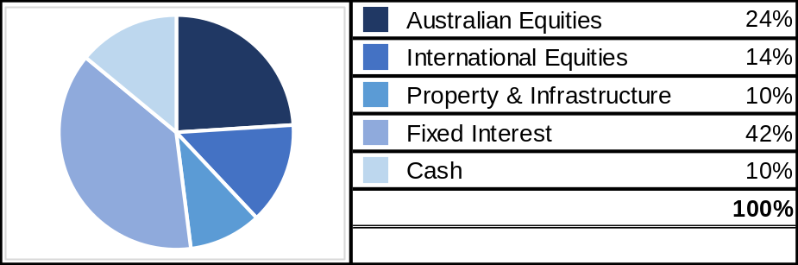
Previous Allocation New Allocation Changes
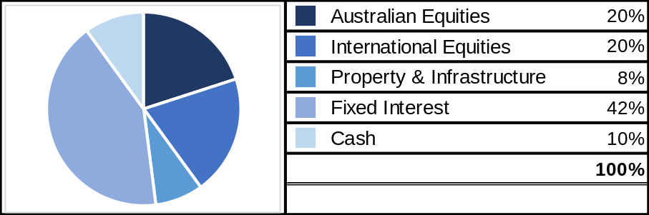

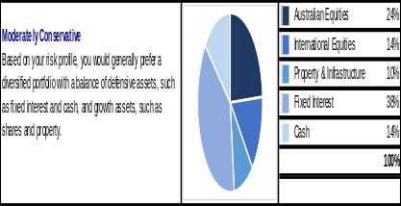
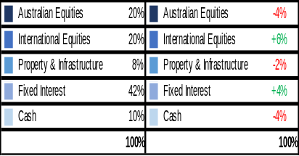
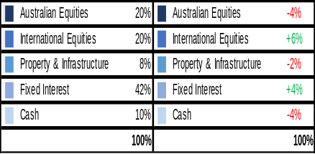
The main difference in this new ‘Moderately Conservative’ Asset Allocation compared to the previous Asset Allocation is an increase in exposure to International Shares, with less exposure to Australian Shares.
These changes are preferable as LONSEC has reported that investing a greater proportion in Global Shares can increase geographical diversification while also leading to increased returns above those from Australian Shares (see Appendix B for further information on ‘Regional Diversification’ from LONSEC Research).
Additionally, the Australian Share Exchange (ASX) tends to follow the same trends and patterns in response to activity in the US and World Share markets.
Property and Infrastructure, while still an important mode of diversification, continues to experience turbulent sector-wide returns in response to global economic factors such as inflation and high interest rates.
We will continue to monitor this sector, however, in the meantime we should look to a combination of International and Australian Shares to provide some more consistent capital growth.

Strategy Recommendation

Tax Rates
When assessing the most tax effective environment for your investment assets, we need to consider the tax that would be payable on any income that these investments will generate. The current tax rates are as follows:

Income Earned in your personal name

Tax rates 2024-25
Taxable income | Tax on this income
$1 – $18,200 | Nil
$18,201 – $45,000 | 16c for each $1 over $18,200
$45,001 – $135,000 | $4,288 plus 30c for each $1 over $45,000
$135,001 – $190,000 | $31,288 plus 37c for each $1 over $135,000
$190,001 and over | $51,638 plus 45c for each $1 over $190,000
* The above rates do not include the Medicare levy of 2.0%.

Income Earned in the superannuation environment
Superannuation in ‘accumulation’ phase - Tax rate = 15%
Superannuation in ‘pre-retirement pension’ phase - Tax rate = 15%
Superannuation in ‘allocated pension’ phase - Tax rate = 0%

Tax on superannuation earnings, contributions and income streams

 | Non-superannuation | Super accumulation and pre-retirement pension phase | Super allocated pension phase
 |  |  | After age 60
Salary/pension income | Marginal tax rate (max 45% + medicare) | n/a | Tax free
Super contributions (SGC, salary sacrifice) | n/a | 15% | n/a
Investment income | Marginal tax rate (max 45% + medicare) | Maximum 15% | Tax free*
Capital gains | Marginal tax rate (50% discount if held for more than 12 months) | 10% (15% if asset held less than 12 months) | Tax free*

Superannuation Contribution Limits

Table 1- Concessional contribution limits

Concessional contributions include employer and self-employed contributions such as salary sacrifice, superannuation guarantee and personal concessional contributions.

Date | Limit (per annum)
Date | To Age 49 | Age 50-59 | Age 60-67 | Age 68-74* | Age75 and over
From 1 July 2017 | $25,000 | $25,000 | $25,000 | $25,000 | SGC only
From 1 July 2021 | $27,500 | $27,500 | $27,500 | $27,500 | SGC only
From 1 July 2022 | $27,500 | $27,500** |  |  | SGC only
From 1 July 2024 | $30,000 | $30,000** |  |  | SGC only

*Must be employed at least 40 hours during any consecutive 30-day period in the financial year you would like to make the contributions.
** From 1/07/2022, work test requirements were removed for all contributions, except personal tax-deductible contributions.

Table 2 - Non-concessional contribution limits

Date | Limit on after-tax contributions | Eligibility Requirements
Date | Limit on after-tax contributions | Under age 67 | Age 67 to 74 | Age 75 and over
From  1 July 2017 | $100,000 p.a. | May bring forward two years of contributions to make a $300,000 contribution in one financial year | Must be employed | Cannot contribute
From  1 July 2021 | $110,000 p.a. | May bring forward two years of contributions to make a $330,000 contribution in one financial year | Must be employed | Cannot contribute
From  1 July 2022 | $110,000 p.a. | May bring forward two years of contributions to make a $330,000 contribution in one financial year |  | Cannot contribute
From 1 July 2024 | $120,000 p.a. | May bring forward two years of contributions to make a $360,000 contribution in one financial year |  | Cannot contribute

Transition to Retirement
The aim of a ‘Transition to Retirement’ strategy is to utilise current legislation to increase superannuation contributions whilst remaining cash flow neutral.
Current legislation allows you (as you have reached preservation age) to commence a non-commutable income stream with your superannuation monies without having to satisfy a condition of release. From age 60, all income received from this income stream are tax free.
The minimum pension amount that you can draw is 4% of your account balance per annum whilst the maximum pension is 10% and is re-calculated in July each year.
The additional income received from your pre-retirement income stream allows you to make additional contributions to superannuation in the form of salary sacrifice. Salary sacrifice contributions are pre-tax contributions and therefore result in a reduction of assessable income. These superannuation contributions are concessionally taxed at a maximum of 15% as opposed to marginal tax rates of up to 47%.
The ‘Transition to Retirement’ strategy results in an increased net inflow to superannuation and therefore a maximisation of your retirement savings in a tax effective manner.

Katrina Mills | Current Position | Transition to Retirement Pension and making salary sacrifice contributions
INCOME EFFECT
Taxable Income (after salary sacrifice) | $58,240 | $22,575
Post-Tax Contribution | Pension | ($1,445) | $24,922
Gross Income | $56,795 | $47,497
Total Tax | -$9,298 | -$0
Net Income | $47,497 | $47,497
SUPERANNUATION EFFECT
Gross Contribution | $9,638 | $43,858
Tax on Contribution (15%) | -$1,229 | -$6,579
Net Contribution | $8,409 | $37,279
Pension Paid | 0 | -$24,922
Overall impact on superannuation account | +$8,409 | + $12,357
TAX EFFECT
Income Tax | -$9,298 | -$0
Contribution Tax (15%) | -$1,229 | -$6,579
Total Tax | -$10,527 | -$6,579

Pre-Retirement Income Stream

Recommendations:
- Katrina, commence a non-commutable pre-retirement allocated pension with $306,516 made up of your HESTA Super rolled over to the recommended pension platform. Your HESTA Super fund will remain open to accept future contributions.
- Katrina, draw down an income stream of $24,922 per annum ($2,237 per month).
- This pension income is to be used to supplement your income that you will salary sacrifice to super.
- By commencing a pre-retirement income stream you are increasing your income in a tax effective manner and therefore allowing you to commence a salary sacrifice arrangement.
- There is an immediate income tax benefit on withdrawal and re-contribution via salary sacrifice, as a result of this strategy.
- The income from a pre-retirement income stream is tax effective income, in that you will receive such benefits as:
  - A deductible amount for tax purposes – which reduces your taxable income.
  - Ability to draw down income from the pension tax free.
Risks:
- Your income stream capital is subject to market performance fluctuations which may have a flow on effect to your income received.
- A condition of the transition to retirement income stream is that it is non-commutable – no lump sum withdrawals can be made until you satisfy a condition of release.

Salary Sacrifice to Superannuation

Recommendation:

- Katrina, salary sacrifice $35,665 per annum ($2,972 per month) to your HESTA Super Fund for the next 5 years.
- Arrange this with your employer/payroll as soon as possible.

Benefits:

- Salary sacrifice contributions are made with pre-tax dollars and therefore you will receive a reduction in taxable income for the contributions that you make.
- Katrina, your salary sacrifice contributions will be taxed at a maximum of 15% compared to a maximum of 32.5% if taken as income.
- The total tax saving for a full financial year is estimated to be $3,948.
- You have increased your NET superannuation contributions by $3,948 p.a. to build a capital base to meet your retirement income goals.

Risks:

- Superannuation benefits are subject to market returns and earning rates are not guaranteed.

IMPORTANT:
It is important that any salary sacrifice arrangement is clearly documented in writing. You should also confirm with your employer that they are going to continue to pay Superannuation Guarantee Contributions (SGC) on the grossed-up amount of your package, i.e. that the SGC will continue to be calculated on the total of your salary + salary sacrificed amount.

Full Financial Year
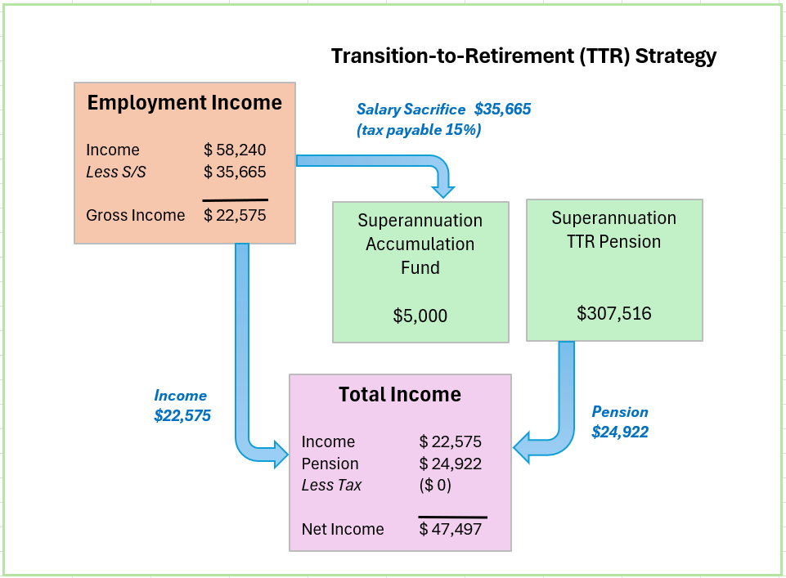

Income Tax & Cash Flow Projections Post Recommendation

Proposed Estimated Tax Liability (full financial year)

Income Source |  | Amount Received | Deduction | Taxable Income | Tax
Salary |  | $71,240
Deductions
Salary Packaging  Salary Sacrifice |  |  | $13,000  $35,665
TAXABLE INCOME |  |  |  | $22,575
TAX PAYABLE |  |  |  |  | $700
Medicare Levy  Low Income Tax Offset |  |  |  |  | $0 ($700)
NET TAX |  |  |  |  | $0

Proposed Estimated Cash Flow

Based on your stated income, expenses and current tax position we estimate your cash flow over one whole financial year to be as follows.

 | Total
Income
Salary  Pension Income Stream | $71,240  $24,922
Sub Total | $96,162
Less Income Tax  Less Salary Packaging | $0  $13,000
Less Salary Sacrifice | $35,665
Net Income | $47,497
Less Budgeted Expenditure | $47,497
Income Surplus | $0

Concessional ‘Catch-Up’ Superannuation Contributions

Katrina, the concessional superannuation contribution cap in years prior to the 2024/25 Financial Year was $27,500 per annum. In the 2024/25 financial year, this cap increased to $30,000 p.a.

Carry Forward Concessional Contributions:

- If you have a total superannuation balance below $500,000 you can carry forward any unused concessional contributions cap amounts that accrue from 1 July 2018 for up to five financial years. This allows eligible members who do not use all of their concessional cap in a particular financial year, to carry forward their unused concessional cap amounts to future years.
- To be eligible to make catch-up concessional contributions in a year, you must meet the following conditions:
  - have a ‘total superannuation balance’ of less than $500,000 as at 30 June at the end of the financial year immediately preceding the financial year in which the concessional contribution is to be made
  - have previously unused concessional contributions cap amounts that have accrued in one or more of the five financial years preceding the year in which the concessional contribution is made.

- Katrina, the following concessional contributions have been made in recent years:

Financial Year | Katrina | Total Allowable Contributions
2019/20 | $5,285.78 | $25,000
2020/21 | $5,734.19 | $25,000
2021/22 | $6,831.85 | $27,500
2022/23 | $7,833.08 | $27,500
2023/24 | $9,379.66 | $27,500
TOTAL | $35,064.56 | $132,500

- Katrina, you therefore have a total of $97,435 in concessional ‘catch-up’ contributions available to you from the 2019/20, 2020/21, 2021/22, 2022/23 and 2023/24 Financial Years.

Overall Superannuation Contribution Schedule

- Katrina, if you contribute the recommended salary sacrifice ($35,655) along with the maximum annual concessional contributions available to you, the net tax saving over the next five years is anticipated to be $19,740.
*It is assumed existing employer contributions and Salary Sacrificing increase to reflect the 12% Superannuation Guarantee rate in the 2025/26 Financial Year and will remain the same through the next 4 years at $44,214 p.a.
 |  | 2024/25 | 2025/26 | 2026/27 | 2027/28 | 2028/29 | Total
 | Concessional Contribution Cap | $30,000 | $30,000 | $30,000 | $30,000 | $30,000
 | Personal Concessional Contributions Available (including ‘carry forward’ contributions) | $127,435 | $105,221 | $88,455 | $67,787 | $48,120 | -
 | Employer Contribution | $8,193 | $8,549 | $8,549 | $8,549 | $8,549 | $42,389
 | Salary Sacrifice | $35,665 | $35,665 | $35,665 | $35,665 | $35,665 | $178,325
 | Total Concessional Contribution | $43,858 | $44,214 | $44,214 | $44,214 | $44,214 | $220,714
 | Taxable Income | $22,575 | $22,575 | $22,575 | $22,575 | $22,575
 | Reduction in Net Tax Payable | $3,948 | $3,948 | $3,948 | $3,948 | $3,948 | $19,740
 | Total Concessional Contribution | $43,858 | $44,214 | $44,214 | $44,214 | $44,214 | $220,714

Strategy Recommendation

Reversionary Pensions

Recommendations:

Katrina, when you commence your allocated pension income stream you should make it reversionary.

Benefits:
- A reversionary pension enables your tax dependant beneficiary to receive your pension account balance remaining within the superannuation environment. All moneys received by the reversionary beneficiary remain in pension phase and therefore all income earned by the fund or capital gains realised by the fund to pay the benefit pension will not be subject to tax.
- If either the deceased or the recipient of the reversionary pension is over the age of 60, the income stream will not be assessable for income tax purposes.
Risks:

- If the income stream is commuted (either rolled into an accumulation fund or lump sums are withdrawn) within six months after the death of the deceased or 3 months after the grant of probate of that deceased person's will or letters of administration of that deceased person's estate, then it is treated as a death benefit payment. Therefore, the moneys would be treated as a lump sum benefit outside of the superannuation environment.

Superannuation Funds

Recommendations:

- Katrina, commence a non-commutable pre-retirement allocated pension with $306,516 made up of your HESTA Super rolled over to the recommended pension platform. Your HESTA Super fund will remain open to accept future contributions and to pay for the insurance premiums for Life insurance cover held within your Hesta Super fund.
  - HESTA requires a minimum balance of $6,000 following a partial transfer to keep your current Accumulation fund open.
- Katrina, draw down an income stream of $24,922 per annum ($2,237 per month).
- Katrina, salary sacrifice $35,665 per annum ($2,972 per month) to your HESTA Super Fund for the next 5 years.
- Invest your funds in line with your Investor Risk Profile which is in line with that of a “Moderately Conservative” portfolio.

Benefits:

- A sector specific asset allocation strategy takes advantage of expert fund managers who specialise in that single sector.
- You will have access to a wide range of investment options with access to more than one specialist manager within each asset class.
- The recommended wholesale fund platform has a wide range of investment options with access to more than one specialist manager within each asset class.
- Your superannuation benefits will be invested under a cost-effective investment platform that provides all the characteristics you will need approaching retirement.
- You will gain ongoing advice from us as your financial adviser as we will have full access to information relating to the recommended superannuation fund. This will enable us to provide thorough and timely advice to you.

Risks:

- The recommended investment’s performance is subject to market fluctuations.
- Investment performance is not guaranteed.

HESTA Super – Account Number 8271574
Katrina, you have a HESTA Super fund invested in the Balanced Growth (100%) option with an approximate balance of $312,516.
The overall asset allocation of your HESTA Super portfolio is:

Asset Class | % of Portfolio
Australian Shares | 22.00%
International Shares | 31.00%
Property/Infrastructure | 16.00%
Other | 7.00%
Fixed Interest / Bonds | 19.00%
Cash | 5.00%
 | 100%

Current HESTA Super Compared to a ‘Moderately Conservative’ Benchmark

Asset Class | Current Portfolio | Benchmark Profile for a Moderately Conservative Portfolio | Deviation
Australian Shares | 22.00% | 20.00% | +2.00%
International Shares | 31.00% | 20.00% | +11.00%
Property/Infrastructure  Other | 16.00%  7.00% | 8.00%  0% | +8.00%  +7.00%
Fixed Interest | 19.00% | 42.00% | -23.00%
Cash | 5.00% | 10.00% | -5.00%

Current Portfolio Historical Performance

Performance of the HESTA Super option at 30 June 2024:

Katrina | 1 year | 3 years | 5 years
Balanced Growth | 9.10% | 5.50% | 6.93%

Master Trust Platforms (Colonial First State)

Your investments in the Colonial First State platform would have a specifically modelled portfolio directly in line with your ‘Moderately Conservative’ Investor Risk Profile. The specific underlying funds that make up your individual portfolio would be:

Katrina
Colonial First State Wholesale Transition-to-Retirement (TTR) Pension – ‘Moderately Conservative’ portfolio

 | % of portfolio
Realindex TTR Australian Share Value  Ausbil TTR Australian Active Equity  First Sentier TTR Australian Small Companies  CFS TTR Index Global Share  GQG Partners TTR Global Equity  CFS TTR Index Property Securities  Pendal TTR Property Investment  Perpetual TTR Diversified Income  Yarra TTR Enhanced Income  Acadian TTR Defensive Income  FirstRate TTR Saver | 8.00%  8.00%  4.00%  10.00%  10.00%  4.00%  4.00%  16.00%  16.00%  10.00%  10.00%
 | 100.00%

Performance of the proposed Colonial First State (CFS) TTR Pension fund invested with a ‘Moderately Conservative’ Asset Allocation at 30 June 2024:

 | % of portfolio | 1 year | 3 years  p.a. | 5 years  p.a.
Realindex TTR Australian Share Value  Ausbil TTR Australian Active Equity  First Sentier TTR Australian Small Companies  CFS TTR Index Global Share  GQG Partners TTR Global Equity  CFS TTR Index Property Securities  Pendal TTR Property Investment  Perpetual TTR Diversified Income  Yarra TTR Enhanced Income  Acadian TTR Defensive Income  FirstRate TTR Saver | 11.00%  11.00%  5.00%  13.00%  12.00%  4.00%  6.00%  6.00%  13.00%  13.00%  6.00% | 11.91%  9.61%  5.10%  17.02%  29.56%  21.19%  20.28%  6.41%  8.45%  8.06%  4.01% | 8.72%  7.41%  1.27%  9.20%  16.08%  4.91%  4.40%  2.91%  3.89%  4.74%  2.20% | 8.63%  9.35%  8.34%  11.09%  15.30%  3.77%  4.40%  2.70%  3.57%  2.74%  1.50%
 | 100% | 11.83% | 6.02% | 6.17%

Performance of the HESTA Super option at 30 June 2024:

Katrina | 1 year | 3 years | 5 years
Conservative | 5.44% | 3.21% | 4.04%

Performance of a ‘like-for-like’ Colonial First State (CFS) portfolio invested with a ‘Balanced to Growth’ Asset Allocation (in line with your current HESTA fund) at 30 June 2024:

 | % of portfolio | 1 year | 3 years  p.a. | 5 years  p.a.
Realindex TTR Australian Share Value  Ausbil TTR Australian Active Equity  First Sentier TTR Australian Small Companies  CFS TTR Index Global Share  GQG Partners TTR Global Equity  CFS TTR Index Property Securities  Pendal TTR Property Investment  Perpetual TTR Diversified Income  Yarra TTR Enhanced Income  FirstRate TTR Saver | 13.00%  12.00%  5.50%  17.00%  16.00%  7.00%  6.00%  10.00%  9.50%  4.00% | 11.91%  9.61%  5.10%  17.02%  29.56%  21.19%  20.28%  6.41%  8.45%  4.01% | 8.72%  7.41%  1.27%  9.20%  16.08%  4.91%  4.40%  2.91%  3.89%  2.20% | 8.63%  9.35%  8.34%  11.09%  15.30%  3.77%  4.40%  2.70%  3.57%  1.50%
 | 100% | 14.91% | 7.59% | 8.23%

Current Portfolio Historical Performance

Performance of the HESTA Super option at 30 June 2024:

Katrina | 1 year | 3 years | 5 years
Balanced Growth | 9.10% | 5.50% | 6.93%

- After considering your current asset allocation, we would recommend investing your funds in the following manner:

Proposed Portfolio

Katrina

Retirement Assets
HESTA Super  Colonial Wholesale TTR Pension (Account # - TBD) | $6,000  $306,516
Realindex TTR Australian Share Value  Ausbil TTR Australian Active Equity  First Sentier TTR Australian Small Companies  CFS TTR Index Global Share  GQG Partners TTR Global Equity  CFS TTR Index Property Securities  Pendal TTR Property Investment  Perpetual TTR Diversified Income  Yarra TTR Enhanced Income  FirstRate TTR Saver | $39,930  $36,859  $16,894  $52,217  $49,145  $21,501  $18,429  $30,716  $29,180  $12,286
Retirement Assets | $306,516

Proposed Asset Allocation

 | Asset Allocation Percentage
Asset Class | Current % | Proposed %
Australian Shares | 22.00% | 20.00%
International Shares | 31.00% | 20.00%
Property | 16.00% | 8.00%
Other | 7.00% | 0
Fixed Interest / Bonds | 19.00% | 42.00%
Cash | 5.00% | 10.00%
 | 100% | 100%

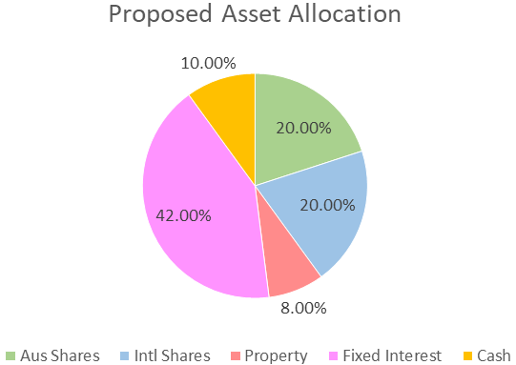
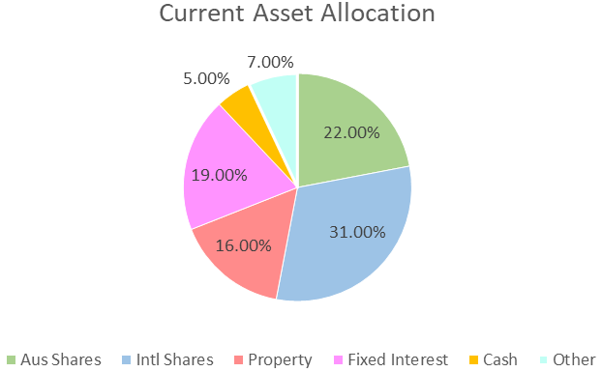

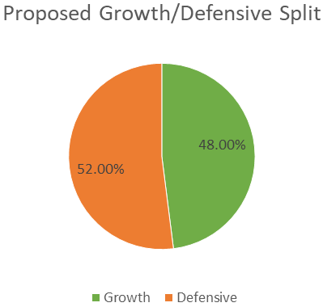
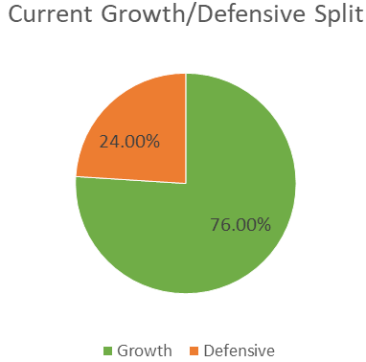

Investment Recommendation
Colonial FirstChoice Wholesale Investments
The FirstChoice Investments is a multi-manager investment solution which combines wide investment choice with a competitive and simple fee structure, backed up by a high standard of service support from Colonial First State.

A minimum total investment of $5,000 ($1,500 for super) is required to establish an account in FirstChoice Investments. A $1,000 minimum initial balance is required if a regular investment plan is set up at commencement of the account. The minimum regular investment plan amount is $100 per month.

Reasons and Benefits
The major features of the Colonial FirstChoice Investments are as follows:

Sector Specific Diversification
A wide range of investment options with access to more than one specialist manager within each asset class. This approach captures the competitive advantages of each manager. We anticipate this will provide higher returns than can be obtained from using diversified funds with, say, only one fund manager.

Simplicity
Consolidated reporting from Colonial First State.

Ease of Management
Automatic investment re-balancing and switching to help you easily and conveniently keep your investment strategies on track.

- We recommend that annual automatic rebalancing is elected.

Highly competitive and simple to understand fee structure
- No entry fee applies to this investment however, with your agreement; your Financial Adviser may wish to charge a one-off fee for upfront costs.
- You can agree with your Financial Adviser to have an ongoing Adviser Service Fee for advice paid directly from your investment. The ongoing fee will be deducted monthly from your investment options.
  - A $50 per month (p.m.) Adviser Service Fee will apply to the new Transition-to-Retirement (TTR) Pension fund.
- No switching fees or exit fees apply to this investment.

Replacement of an Existing Product

Type of Fee or Cost | HESTA Super | Colonial Wholesale Pension Fund
Contribution/Entry fee – this is the fee for initial and subsequent contributions. | Nil | Nil
Withdrawal/Exit Fee – this is the fee for each withdrawal you make | Nil | Nil
Switching Fee – fee charged for switching between investment options in the super fund. | Nil | Nil
Administration Costs – are the fees and costs that cover the operation of the fund. They include admin, member and other fees charged by the product issuer | $52 p.a. +  0.19% p.a. | Nil
Adviser Service Fee – additional fee paid to financial adviser | Nil | $50 p.m.
Annual average cost – on Total $306,516 investment | $636 p.a. | $600 p.a.

Outcomes Post Implementation - Katrina:
- The overall fees will decrease by approximately $36 per annum.
- The ‘like-for-like’ Colonial First State Wholesale ‘Balanced to Growth’ portfolio has outperformed your current HESTA Super Fund over the past 5 years by an average of 1.30% p.a.
- Based on your current balance, this equates to $9,522 per annum ($47,610 over a five-year period).
- The Colonial First State Wholesale ‘Moderately Conservative’ portfolio has outperformed the ‘Conservative’ option for your HESTA Super Fund over the past 5 years by an average of 2.13% p.a.
- Based on your current balance, this equates to $3,998 per annum ($19,990 over a five-year period).
- The historical performance figures outlined on the previous pages are NET of the respective investment fees. The investment fees for the above two options are as follows:
  - HESTA Super (current) – 0.66%
  - CFS portfolio (proposed) – 0.77%

Colonial FirstChoice Management Fee
Colonial FirstChoice charges a Management Expense Ratio to cover their administration costs and the associated costs of managing your funds. Based on your proposed portfolio value, we have provided an estimation of the costs you will pay.

Katrina
Colonial FirstChoice Wholesale TTR Pension | MER  % | Amount invested   $ | Estimated  fee  $
Realindex TTR Australian Share Value  Ausbil TTR Australian Active Equity  First Sentier TTR Australian Small Companies  CFS TTR Index Global Share  GQG Partners TTR Global Equity  CFS TTR Index Property Securities  Pendal TTR Property Investment  Perpetual TTR Diversified Income  Yarra TTR Enhanced Income  Acadian TTR Defensive Income  FirstRate TTR Saver | 0.64%  1.04%  1.14%  0.36%  1.00%  0.34%  1.09%  0.95%  0.80%  0.64%  0.53% | $24,572  $24,572  $12,286  $30,716  $30,716  $12,286  $12,286  $49,145  $49,145  $30,716  $30,716 | $157  $256  $140  $111  $307  $42  $134  $467  $393  $197  $163
Total ongoing fees | 0.77% | $306,156 | $2,366

 Colonial FirstChoice’s Management Fee is calculated on the value of your total portfolio. As such we have used your proposed portfolio to estimate your annual ongoing fee.

Please note that these fees are built into the unit prices and are reflected within the performance figures of the fund. They are not transactions that are deducted from your account.

What is paid to your adviser

Plan Fee
You have agreed to a Plan Fee of $1,650 (inclusive of GST), which will be deducted from the recommended superannuation fund.

Upfront and Ongoing Fee Disclosure

The following is provided to assist you to gain a clear understanding of the payments and benefits that Pareto Group Pty Ltd, our associates and I will be entitled to receive for services provided to you, if you adopt the recommendations in this plan.

 |  |  | Total Fee Paid by Client |  | Total Payable to Financial Service Licensee/Financial Adviser and /or its Associates
Investment Details |  | Amount Invested | (%) ($) |  | Initial  (%) ($) |  | Ongoing  (%) ($)
Colonial FirstChoice Wholesale Transition-to-Retirement Pension |  | $306,516 | Flat Fee | $1,650 | Flat Fee | $1,500 | Flat Fee | $600 p.a.
Total |  | $306,516 |  | $1,650 |  | $1,500 |  | $600 p.a.

* The ongoing investment amount has been annualised to provide you with a clear picture of how fees are paid from your investment. Your regular contribution is placed into the individual underlying funds according to the % split of the allocation of your original investment.

The agreed Ongoing fee is the way we charge for the ongoing service that we provide. If at any time you wish to discuss this you can do so.

I am an authorised representative of Pareto Group Pty Ltd (ABN 11 155 278 078), which holds an Australian Financial Services Licence (AFSL #418700).

Disclosure Statement

To help you understand the full benefits, details and risks of our recommended products, please read the Product Disclosure Statements that we will provide you.

Please let us know if you have any questions.

Cooling-off periods

After investing in a financial product, you have a “cooling-off” period in which to change your mind if you don’t think the product meets your needs. The cooling-off period usually starts when you’re told the product has been set up. The length of the period varies with each product.

Each Product Disclosure Statement explains your cooling-off rights.

If you wish to cancel a product, please tell us in writing so we can contact the product issuer within the time restrictions.

No guarantee

The investments we recommend for you must be appropriate for you. However, we don’t guarantee they’re the best available or that they’ll perform in a particular way. Product performance depends on the features and risks described in the Product Disclosure Statements given to you.

Please take the time to read the PDS and understand the products we have recommended. If you have any questions, please contact us.

Tax

There will be tax implications if you act on this advice. We recommend you ask a tax professional to assess the impact on your short and long-term financial positions.

Are My Product Recommendations Restricted?

Non Superannuation Products

Yes, when making non superannuation product recommendations I can only choose products from our Approved Product List (APL). This list is compiled by a dedicated Investment Committee, made up of Research Manager, Directors and Representatives who carefully analyse investment products, prior to including any product on the APL. The Committee utilises leading industry research houses to assist with their analysis.

The APL is regularly reviewed to ensure that all funds, managers and investment companies continue to meet our ongoing stringent requirements.

Superannuation Products

Yes, when making superannuation product recommendations I can only choose products from our Approved Product List (APL). However, if you have a superannuation product that is not on our APL, I am still able to make recommendations in relation to that fund providing I have conducted the necessary research and have a thorough knowledge of the fund.

What is My Responsibility to You?

I am responsible for providing you a ‘clear, concise & an effective’ method of communicating my recommendations to you. The recommendations are based on your goals and objectives, personal and financial situations, and other information collected from you. The recommendations are appropriate for your needs and current situation.

As the SoA is specifically prepared for you and based on your situation, I do not take any responsibility for any third-party persons acting on all or on a part of any advice or recommendations made in this SoA.

Do I Guarantee the Investments I have recommended?

No. By law, the investments I have recommended must be appropriate to you, however, I do not guarantee that the recommended investments are the best for you or that they will perform in a certain way.

Your Financial Plan

In preparing this plan we have taken into account your specific goals and objectives, and have designed an appropriate strategy that aims to accomplish these.

It is important to appreciate that we live in an ever-changing world. Accordingly, it is probable that, overtime, the basis of our calculations (inflation rates, investment rates etc.) will change, as will your own requirements and expectations. It is therefore recommended you review your plan on a regular basis to ensure you are still on track to achieve investment objectives.

It is essential to have your investment portfolio reviewed to ensure that the investments are working to their maximum potential and any changes to the investment markets, taxation etc. are promptly and correctly responded to.

Next steps

How to get started

To implement our recommendations in this plan, please do the following:

- Make sure you read this Statement of Advice and Product Disclosure Statements
- Contact us if you have any questions
- Tell us immediately if any information is incorrect
- Complete the application forms in the Product Disclosure Statements
- Sign and date the Authority to Proceed
- Return the forms to us
- Retain a copy for your records

Finally

Please note, as with any investments, their future value may fluctuate, particular rates of return cannot be guaranteed and you may not get back what you originally invested. We have provided a brief summary of the managed investment products recommended, however, you will need to study the investment statements of the recommended products carefully before you decide to invest.

Summary

Plan Implementation

Katrina, you have taken another next step to reach your personal and financial goals and objectives. The most important stage of the process is to put the plan into action. There are a number of steps required for the implementation of this plan:

Action | Anticipated Start Date | Estimated Completion Date | Responsibility
Authority to Proceed returned with any amendments | - | 6 August 2024 | Katrina
Applications returned | - | 6 August 2024 | Katrina
Pension Application Process | 6 August 2024 | 20 August 2024 | Andrew Lord
Confirmation of all in place | - | 20 August 2024 | Andrew Lord
Detailed review of the progress | 27 January 2025 | 27 January 2025 | Andrew / Katrina

Appendix A – LONSEC Report Package for New Funds

Appendix B – LONSEC Research ‘Regional Diversification’ Chart

